- Dates to Note  Term 1:  Bunnings BBQ 26th February  Teddy Bears Picnic 4th March  Labour Day 14th March  Term 1 End 8th April  30th Birthday 9th April  Term 2:  Anzac Day 25th April  Term 2 Start 26th April  Queens Birthday 13th June  Term 2 End 24th June  Term 3:  Term 3 start 11th July  Term 3 end 16th Sept  Term 4:  Term 4 start 3rd October  Melbourne cup 1st November  Term 4 end 20th Dec  Fundraising  The fundraising team have some exciting activities coming up for 2022. Our first fundraising event is a Bunnings BBQ. Due to COVID-19 we must have a minimum of 4 people at the BBQ at all times. If you are able to volunteer an hour or 2 on the day the preschool would be very appreciative. There is a roster at the front of the kinder, please add your name to that if you can. | Bittern Preschool Committee Newsletter  Welcome!  What a fabulous start to 2022 we have had! We have been so excited to welcome old and new families to our Bittern Preschool community. We have a fun filled year ahead, and we cant wait to get to know you all.  Each month a newsletter will be posted onto Storypark, in this newsletter will be all the events coming up and any news from the Committee of Management.  If you have something you would like to add to the newsletter, please get in touch.  As you know bittern Preschool is run by a Committee of Management, we are so thankful for the current group of volunteers for 2022. We still need to fill the position of the Vice President. If you think this is the position for you, please let us know, or if you have any questions about the position, Sarah or Jamie-lee would be more then happy to chat.  All families should have been sent their link to join StoryPark, this is where your child’s updates will be sent to, and any important information about the happenings at kinder. Please get in touch if you are having issues accessing StoryPark.  Get To Know Your Committee of Management  President: Jamie-lee Davis  Vice President:  Secretary: Rebecca Mioduszewski  Treasurer: Alison Souter  Maintenance Officer: Jaimie Farley  Fundraising Officer: Sam Birchall  Grants Officer: Yolanda Morrison  Purple Group Rep: Nina Unthank  Purple Group Rep: Laura Brasher  Green Group Rep: Jessica Dixon  Blue Group Rep: Yolanda Morrison  Blue Group Rep: Rhiannon Glenn  Fundraising Sub: Casey Jones  Fundraising Sub: Laura Brasher  Fundraising Sub: Nina Unthank  General Committee:Linda Chahwan  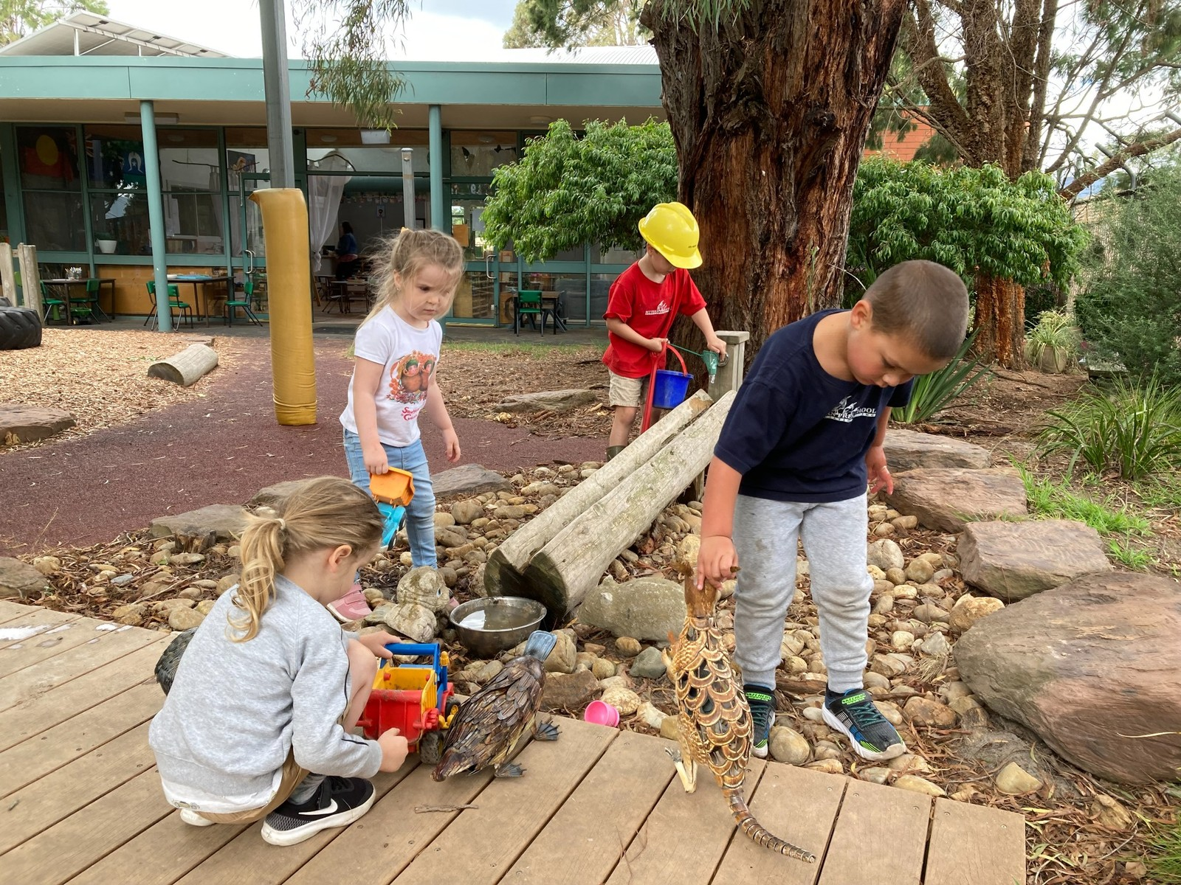  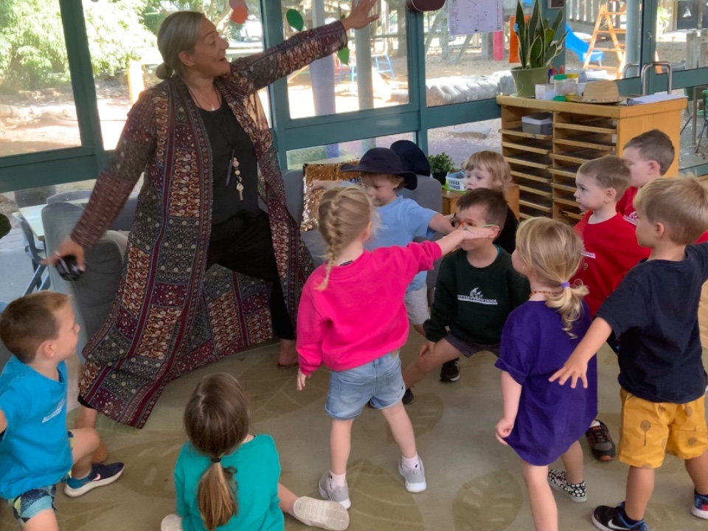  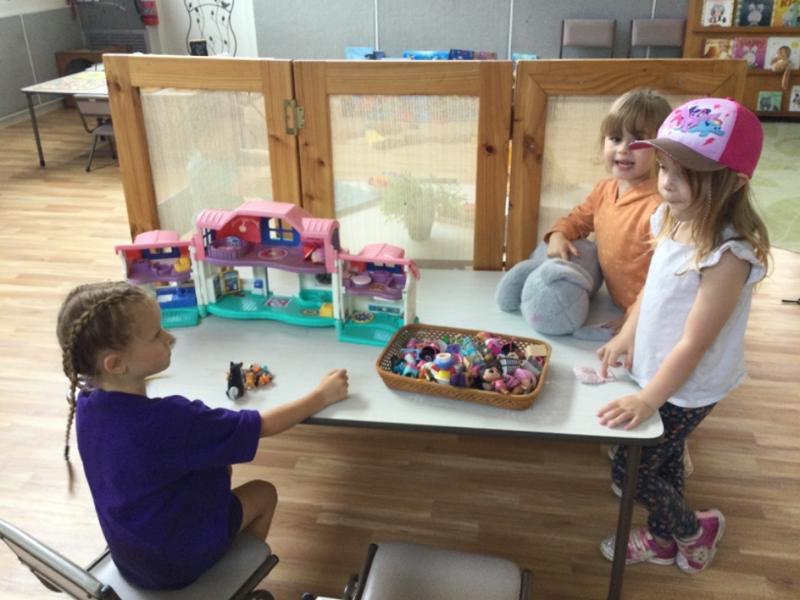  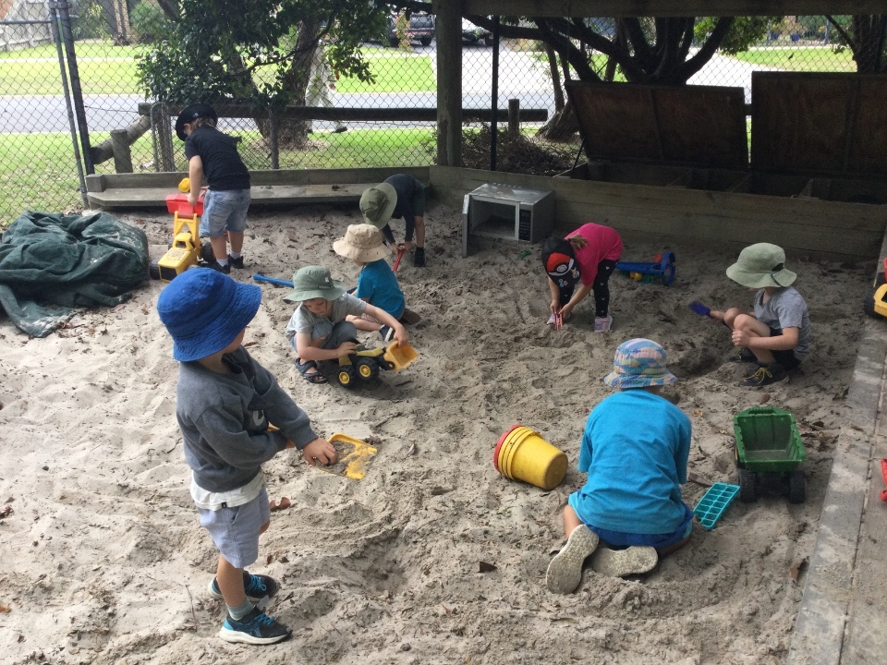  Moments at Bittern Preschool  Reminders for coming to preschool:  Please remember to pack a hat each day your child attends kinder, and to apply sunscreen before your child begins their session.  It is important to ensure you pick your child up on time at the end of their session, we understand that traffic and other things can pop up, if this is the case, please call the preschool to let us know. We do have a late fee, if late pick ups become frequent we will have to implement this.
Contact Us  Company Name  Bittern Preschool  Street Address  31 Sudholz St  City, ST Zip Code  Bittern, 3918  Phone  0407 622 325  Email  Bittern.kin@kindergarten.vic.gov.au  Website  www.bitternpreschool.com.au | The next Committee meeting will be held on the 2nd of March 2022, at 7pm, at the kindergarten. All families are welcome to attend even if they are not a part of the Committee of Management. Attending the meetings is a great way to have a voice in the way the kindergarten operates.  Spare Clothes:  If you have any larger sized clothes, size 4-6 that you no longer require, we would love to take them off your hands. Our spare clothes pile is running very low.  Uniforms:  Uniforms can be purchased from https://eduthreads.com.au/collections/bittern-pre-school. These uniforms are not compulsory, however they are a great way to protect “home” clothes. Bittern Preschool also receives a small percentage of each sale and helps to purchase resources for the kinder. There are some samples in the foyer of the preschool that you are more then welcome to try on.  Cardboard Boxes:  The kinder children love to build and create! We would be so appreciative of any donations of cardboard boxes! Please no toilet paper rolls.
