Bittern Preschool
Information Booklet
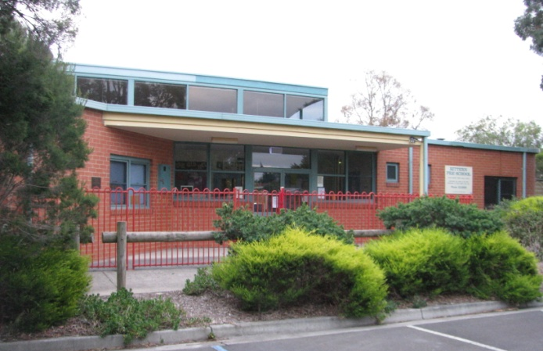
2022
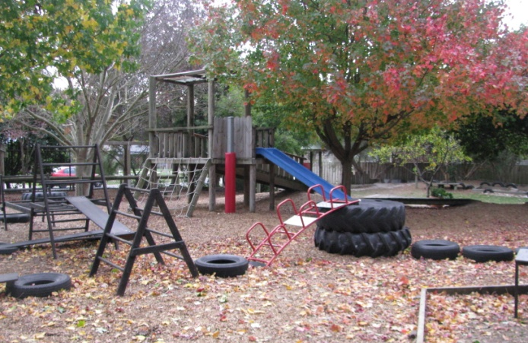

Index

Contact Information 0
Welcome to Bittern Preschool 0
A Brief History of Bittern Preschool 1
Bittern Preschool Groups 2
Three Year Old Group 2
Four Year Old Group 2
Introduction to the Staff 3
The Philosophy of Bittern Preschool 6
School Transition Statements 8
The Victorian Early Years Learning and Development Framework [VEYL&DF] 9
Preschool Routine and Parental Involvement 12
What to bring to Preschool each session: 12
Clothing 12
Water and Fruit Routine 12
Parent Participation 13
Notices 13
Collector’s Corner 13
Delivery and Collection of Children 13
Parking 14
Speed 14
Your Child’s Work 15
Birthdays at Preschool 15
Fundraising 15
Bush Kinder
Procedures 17
Policies 21
Fees Policy 21
Enrolment Policy 25
Children must turn 4 years by April 30th in the year they attend Preschool. 25
Bush kinder 25
No Jab, No Play Legislation 25
Late Collection of Children Policy 26
Behaviour Guidance Policy 26
Procedure for Dealing with Complaints Policy 27
Privacy Policy 27
Photography Policy 28
Toilet Training policy 28
Grievance and Discipline Policy 28
Children of Staff Policy 28
Sun Protection Policy 28
Healthy Eating Policy 29
Orientation Policy 30
Bittern Preschool Committee of Management 32
Bittern Preschool Committee Members' Position Descriptions 33
Contact Numbers 36

Contact Information

Bittern Preschool Association Incorporated
ABN: | 95 722 128 104
Address: | 31 Sudholz Street  Bittern  VIC 3918 | Postal Address: | PO Box 34  Bittern  VIC 3918
Phone: | 0407 622 325
Email: | bittern.kin@kindergarten.vic.gov.au
Website: | www.bitternpreschool.com.au
Facebook: | https://www.facebook.com/bitternkindergarten

Welcome to Bittern Preschool

Welcome to Bittern Preschool, in 2021 we are offering two groups of 4 year olds (Green and Blue group) and one group of three year olds (Purple Group). The Preschool year is a very happy, exciting and rewarding time for your child and your family.
Preschool provides your child with the opportunity to freely socialise, explore feelings about themselves, experiment and be wonderfully creative, all within a safe and comfortable setting. Your child will be encouraged to contribute to, and participate in both group activities and individual ones. By sharing their experiences, they begin to develop a positive self-esteem and at the same time begin to develop an appreciation of the contributions others can make.
A child who has been eased into Preschool is well on the way to feeling confident and independent, which is great preparation for future steps in their learning. The variety of interesting experiences provided at Preschool cover the different areas of a young child’s development. While a child is involved in an activity they are developing their social skills and concepts about the world in which they are a part – such as shape, size, weight, colour, etc. As they learn and play in a group environment, they practice the skills of being patient, listening to another’s contribution, sharing their own ideas and most of all...HAVING FUN !
The Preschool year is also a wonderful opportunity for you, the parents, to participate and contribute at various levels. You will make friendships with other families and enjoy knowing that you belong to and are an important member of the Preschool community.

A Brief History of Bittern Preschool

It all began with a small notice in the local paper inviting people interested in starting a Preschool in Bittern to attend a public meeting at the Bittern Hall. In August 1989 the Bittern Preschool Development Working Party was formed from local families and councillors. The work began. First to prove the need and viability of a Preschool in Bittern, and then to raise funds, select a site, get a building constructed and equipped to open. Over the next two to three years this small group of people attended many meetings in Shire offices, homes and halls and did countless fundraising work to get Bittern Preschool established.
In May 1991 the first Annual General Meeting of the Bittern Preschool was held at Bittern Hall. All of the original development party volunteered as the first Bittern Preschool Parent Committee with added new members. On the 11th November, 1991 Hastings Council took possession of the new building from Builder: J. J. Wilson and Architect: Greg Carter. On 21st November 1991 with the first Bittern Preschool Committee Meeting was held in the new Preschool (BYO chair and mug!), followed by moving in of equipment and interviewing of staff. Thursday 30th January 1992, heralded the first 4 year old group session held in Bittern Preschool. One group of 25, 4 year olds attended 4x2.5 hour sessions a week with teacher Candice Drew and assistant Wendy Warden. Two groups of 16, 3 year olds attended 1x2 hour session each week with teacher Gail Henley and assistant Helen Evans.
The Bittern Preschool was developed by the community for the community and our thanks go to:
- Those families who began it all,
- The local Council for our land, building and continuing maintenance,
- Local businesses and supporters (in particular Bittern Market) for their ongoing help and support,
- The many past parent committee members (volunteers) who have worked to maintain, operate and improve this community run Preschool.

Bittern Preschool Groups

Three Year Old Group
Purple group
 | Timetable |  |  | Staff
 | Tuesday | 8:00am – 10:30am |  | Teacher: | Katie Kuune
 | Thursday | 8:00am – 10:30am |  | Assistant: | Caroline Tearle

Four Year Old Group
Blue Group
 | Timetable |  |  | Staff
 | Monday | 8:00am – 1.30pm |  | Teacher:  Assistant | Jacinta McGill  Katie Kuune
 | Wednesday | 8:00am – 12:00pm |  | Teacher:  Assistant: | Jacinta McGill  Katie Kuune
 | Thursday | 11:00am – 4.30pm |  | Teacher:  Assistant: | Jacinta McGill  Annelise Calderwood

Green Group
 | Timetable |  |  | Staff
 | Tuesday | 11:00am – 4:30pm |  | Teacher:  Assistant: | Nicholas Peyton  Annelise Calderwood
 | Wednesday | 12:30pm – 4:30pm |  | Teacher:  Assistant: | Nicholas Peyton  Caroline Tearle
 | Friday | 8:00am – 1.30pm |  | Teacher:  Assistant: | Nicholas Peyton  Caroline Tearle

Introduction to the Staff

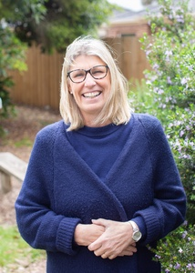
Jacinta McGill
Teacher
Hello my name is Jacinta.
This year I will be working in the Blue group on Monday, Wednesday, and Thursday
I am delighted to be working alongside such a wonderful team of educators and also getting to know a new community of children and families. Having lived and worked on the Mornington Peninsula for 20 years I understand the unique lifestyle and qualities our area has to offer!
I obtained a Bachelor Degree in Early Childhood (Monash University) in 2014. The last four years I have been a Preschool Teacher for the City of Casey. Previously I worked for 8 years as a Diploma trained assistant at a kindergarten in Frankston South, while completing my studies.
I have three passions in life: children, sport and the beach. As a parent I have been actively involved in all of our children’s learning activities, including surf lifesaving, athletics, football and netball.
Early childhood learning is very important to me. Having four Children myself (three boys and a girl), I have experienced and witnessed first hand benefits as a teacher and a parent to how Preschool can enhance your child’s growth and wellbeing.

Nicholas Peyton
Teacher

Caroline Tearle
Assistant

Hello
My name is Caroline, I love kinder and I have had the pleasure of working with children all my working life. I also enjoy meeting new people and kinder gives me this opportunity. I have lived in Crib Point all my life and enjoyed my childhood in this friendly environment.
Kinder is a wonderful time to see your children grow and learn new skills in a friendly environment where they have fun. So much learning, creativity, growing and fun is had in this year and I feel very privileged to share in this. I hope you enjoy your time at Kinder just as much as we enjoy teaching your child.

Katie Kuune
Assistant

Hello my name is Katie
I was lucky enough to have started at Bittern Preschool in 2019 as an educator with the 4 year old’s. I have really enjoyed getting to know the children and their families this year.
I live with my husband, three children (two of which attended Bittern Preschool) and our various pets in Crib point.
This year in addition to working with the 4’s, I will be running the 3 year old program.
I am so looking forward to meeting all of our new families, and creating a play based program that centres around your child’s interest, building on their confidence as communicators, supporting imagination, curiosity, enthusiasm and persistence.

Annelise Calderwood
Assistant

Hello, My name is Annelise and it is pleasure to work alongside the children, staff and families at Bittern Preschool. I am very excited to get to know the children and their families and become part of the Bittern Pre School Community. I will be working across both Green and Blue groups. And look forward to being a part of the children’s kindergarten journey.
I have worked in the Early Childhood Sector for nearly 10 years, after completing my certificate 3 in 2010 and then my diploma in Early Childhood in 2012. I undertook a range of different roles including Room Leader of the Kinder 3’s room. Which I loved.
I am very passionate about working with children and love to keep updated with the latest teaching methods and practices. In the future I would love to further my qualifications & enrol to do my bachelor of early Childhood education.

The Philosophy of Bittern Preschool

The basic premise and philosophy of early childhood education is founded on the knowledge that:
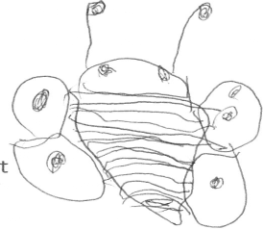
- Each child has the right to play and interact in a safe and welcoming early childhood environment.
- Each child develops at a different rate.
- Children learn through play and that play should be fun!
All children have a natural desire to learn. All they need is opportunities to do so, and the skills necessary to benefit from the opportunity.
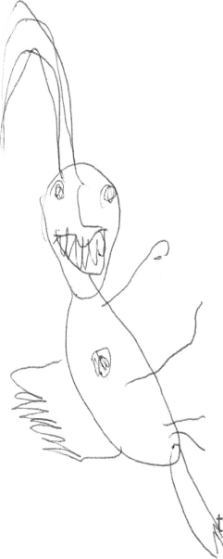
The teacher, who has a minimum of 3 years training in early childhood development and education, will individually observe and make records on a child’s behavior and development. From these records the basis of the program and activities provided by the Preschool will be formed. Much of these activities will be relaxed and unstructured so the child has the chance move around through activities at their own pace. Each child is at a different stage of development and maybe highly skilled in one area and yet need help in another. As most children learn from their total environment learning occurs through our senses of sight, sound, smell, touch, and taste, many of the activities will be sensory to improve and refine these skills.
The program will also be based around our environment, the community and popular festivals. It will incorporate learning skills which will help in the future with maths, reading, music, sport, science, dramatic play, creative arts and people skills.
The skills we seek to develop and some of the activities that do so:
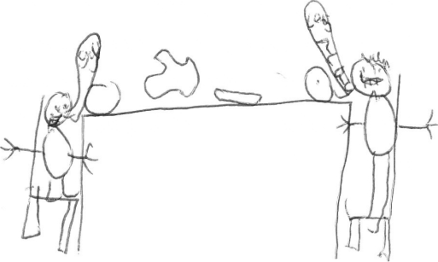
Cognitive Thinking
- To problem solve.
- To observe.
- To concentrate and complete.
- To visually perceive and remember differences in shape, colour, size and position through use of puzzles and games.
Language
To understand and use language confidently to express ideas and feelings, communicate with others in stories, discussions and general play.
Emotional
To recognize how you feel, why you feel it and that all emotions are acceptable. It may just be necessary to modify how you express them when you feel this way, explored through dramatic play, discussion, stories and playing with others.
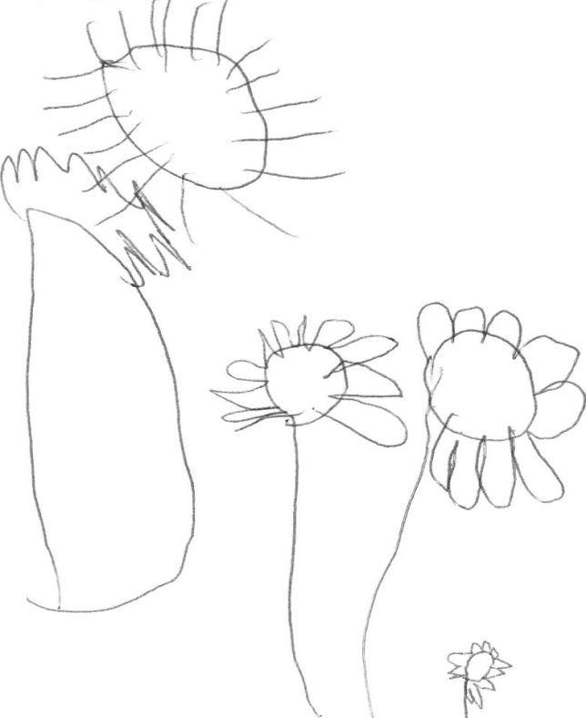
Social Skills
- To learn to defend your own rights and ideas.
- To learn to compromise, recognize and accept others rights and ideas.
- To be able to play alone or with others and be confident and happy either way.
- Activities are provided inside and outside. Fine Motor Skills
Fine motor skills are those necessary to make your fingers do the work. They are essential for a child to hold a pencil, cut with scissors, paste, paint, draw, thread, manipulate puzzles, build with objects, and participate in action songs that require coordinating eye and hand movements.
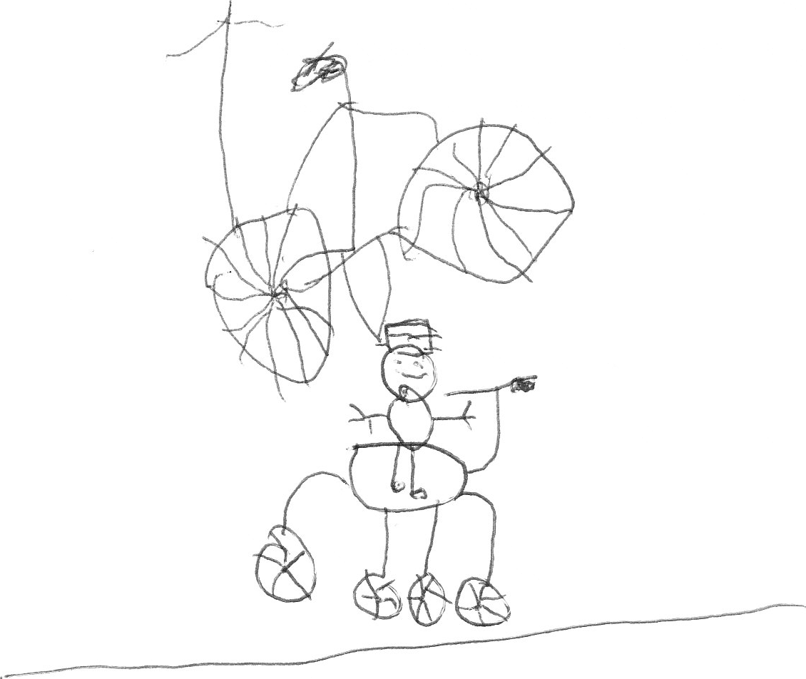
Gross Motor Skills
Gross motor skills involve large muscle groups and are required for outside play. They are essential for a child to jump, climb, run, balance, dance, and handle balls.
All these skills are of equal importance in a child’s development. They are skills for life and will be developed and refined as a child grows through to adulthood. They are not simply prerequisites for school.
Our purpose as teachers is to work alongside parents and help a child be confident, happy and able in his or her own personal skills. Furthermore, to encourage each child to participate as a member of a group, and to learn with eagerness and enthusiasm. Our aim is that the child learns and has the most fun possible.

Child safe standards
Victoria is introducing compulsory minimum standards that will apply to organisations that provide services for children to help ensure the safety of children. The child safe standards form part of the Victorian Government’s response to the Betrayal of Trust Inquiry.
As a part of our compliance to these standards, Bittern Preschool is committed towards:
- promoting the cultural safety of Aboriginal children
- promoting the cultural safety of children from culturally and/or linguistically diverse backgrounds
- promoting the safety of children with a disability
- promoting all children’s right to feel safe and be safe at all times

School Transition Statements

In 2009 the Victorian Government introduced Transition Statements as a part of the Transition to School process.
Each child who attends as a part of a Funded Kindergarten program is to receive a transition statement at the end of the year. This statement is written by both families and teachers, and is forwarded to the school chosen by you for your child.
These statements help to give schools important information which will help to settle your children into the school system, and better prepare schools to be ready for your child. At the start of Term 4, Part 1 of the statement will be sent home for you to complete and the teachers will complete Part 2. Once both sections are complete, parents and teachers may wish to meet to discuss the statement before it is forwarded to the school, if this is the case please speak with your child’s teacher early in term 4 to arrange a time.
The statements focus on the 5 objectives of the Victorian Early Years Framework, those being Identity, Wellbeing, Community, Learning and Communication (discussed further below). Once complete, one copy will be forwarded to the school, one copy kept on record at the preschool and a copy will also be given to the families to keep as a record of their child’s progression at the end of their Kindergarten year.

The Victorian Early Years Learning and Development Framework [VEYLDF]

The Victorian Early Years Learning and Development Framework have been developed in partnership with the Department of Education and Early Childhood (DEECD) and the Victorian Curriculum and Assessment Authority and brings together the national Early Years Learning Framework and the Victorian Essential Learning Standards (VELS). It stands to work as a link between preschool and school and the curriculum being taught to your children. The framework is about strengthening children’s learning and development in the critical years of early childhood, during the age of 0-8 when brain development is at its peak. The Framework has 5 outcomes (discussed below) and identifies what children should know and be able to do from birth to 8 years of age. Being as Victoria wide framework, this means that all professionals working with children from birth to 8 now have a common understanding of children’s learning and development over this period. The framework recognizes that children’s first and most important learning happens with their families and it supports a partnership between families and all professionals who support their learning and development throughout this period.
The Victorian Framework uses five outcomes to describe the key elements of children’s learning and development. These are:
- Children have a strong sense of identity (IDENTITY)
- Children are connected with and contribute to their world (COMMUNITY)
- Children have a strong sense of wellbeing (WELLBEING)
- Children are confident and involved learners (LEARNING)
- Children are effective communicators (COMMUNICATION)

Within each outcome there are standards that describe where the child is at developmentally and these are set out in a table system which aligns with the VELS used by Primary Schools throughout Victoria. Below is a brief overview of each outcome, as described within the Victorian Framework.
Outcome 1: Children have a strong sense of Identity.
Relationships are the foundations for children’s construction of identity. When children’s experiences of relationships and places are positive they develop an understanding of themselves as significant and respected and feel a sense of belonging. Accordingly, children need to build secure attachment relationships in the family and then with caring adults outside it.
As they develop a strong sense of self, children learn to interact with others with care, empathy and respect. As they show interest in other children and in being part of a group, they learn to play constructively with other children and begin to develop friendships. Later in early childhood, children learn how to behave appropriately in a range of social situations, and can identify and accept that there are consequences for their actions.

Outcome 2: Children are connected with and contribute to their world
Children experience living and learning with others from birth; within families, early childhood settings and local communities. Having a positive sense of identity through experiencing respectful, responsive relationships strengthens a child’s interest and skills in being active participants in their communities. As children move into early childhood settings and then schools they broaden their experiences as participants in different relationships and communities.
Children learn to live interdependently with others and with places when they participate collaboratively in everyday routines, events and experiences and have opportunities to contribute to decisions. Later on, they are introduced to the idea of the classroom being a community and learn to work in teams.
Children also become aware of themselves as part of the environment and the broader society. They become aware of the impact the environment can have on them, through experiences such as wearing sun protection, and exploring how and why environmental factors affect their lives. They begin to participate in a range of experiences, such as recycling and taking responsibility for group or class resources.

Outcome 3: Children have a strong sense of wellbeing
Wellbeing incorporates both physical and psychological aspects and includes good physical health, feelings of happiness, satisfaction and successful social functioning. Early childhood is a period in which the foundations of social, emotional and spiritual wellbeing are laid down. This begins with the development of a fundamental trust and confidence that their needs will be met by an accepting, safe environment. Throughout this period, children learn to seek out new challenges, make new discoveries and celebrate their own efforts and achievements and those of others. A strong sense of wellbeing provides children with confidence and optimism, which maximises their learning potential, encouraging the development of their innate exploratory drive, a sense of agency and a desire to interact with responsive others.
Wellbeing is correlated with resilience, providing children with capacities to cope with day-to-day stress and challenges. The readiness to persevere and ‘have a go’ when faced with unfamiliar and challenging learning situations creates the opportunity for success and achievement. It also teaches children to accept when their expectations are not met. Children also gain a basic understanding of the aspects of a healthy lifestyle and good nutrition in this period. A healthy diet is essential to healthy living and enables children to be active participants in play. Early childhood settings provide many opportunities for children to experience a range of healthy foods and to learn about food choices from educators and other children.

Outcome 4: Children are confident and involved learners
During childhood, children not only learn knowledge and skills that form the foundations of their later achievement, they also develop dispositions for learning. These dispositions are fundamental to ensuring that their learning is a lifelong process. When children express wonder and interest in their environments, are curious and enthusiastic participants in learning and use play to investigate the world, they begin to develop positive dispositions for learning. They develop the view that learning is exploratory, fun and rewarding and they use their imagination and curiosity to generate ideas. Later in the early childhood period, they begin to reflect on their own thinking processes, and on those approaches that they believe will help them learn most effectively. They begin to record their feelings and understanding about learning, noting where improvements could be made and reflecting on the effort they put into particular tasks.

From the earliest years, children solve problems and use the strategies they learn to apply to new situations. They use reflective thinking to consider why things happened and what they can learn from experiences. They use their senses to explore the world around them and begin to develop simple explanations for observed phenomena. Active involvement in learning builds children’s understandings of concepts and the creative thinking and inquiry processes necessary for lifelong learning. They can challenge and extend their own thinking and that of others and create new knowledge in collaborative interactions and negotiations. Children’s active involvement changes what they know, can do and value and transforms their learning.

Outcome 5: Children are effective communicators
Children are born eager to communicate with others. They begin by using gestures, visual and non-verbal cues, sounds, language and assisted communication in forming relationships. Most children are innately social and creative and motivated to exchange ideas, thoughts, questions and feelings. Children respond non-verbally and verbally to what they see, hear, touch feel and taste; and they explore sound and movement patterns to sing songs, chants and rhymes.
Children express ideas and make meaning using a wide range of media. They share the stories and symbols of their own culture re-enact well-known stories; and use the creative arts, such as drawing, painting and sculpture, drama, dance and movement, to express ideas and make meaning. They create and explore imaginary worlds through dramatic play. Later on, they make artworks that communicate ideas and concepts, observations and feelings.
Children’s rich spoken language, as well as their gestures and actions, underpin the development of basic literacy and numeracy concepts, such as the sounds of language, letter sound relationships, concepts of print and the ways the texts are structured.

Preschool Routine and Parental Involvement

What to bring to Preschool each session:
- Your child’s lunch or healthy snack (see Healthy Eating Policy).
- A labelled drink bottle for water only.
- A change of spare clothes, underwear and socks.
- In Summer: a hat and sunscreen lotion (see Sun Protection Policy).
- In Winter: gumboots, warm coat and hat.
All should be brought to Preschool in a large, NAMED and easily usable bag or container.

Clothing
As your child will be involved in many activities, they will need comfortable clothes that are allowed to get dirty. This will give children the freedom to experience all things necessary for full participation in the Preschool program. The children should wear serviceable clothing that is easy to self manage (no belts, buckles, braces or jumpsuits which your child cannot undo), a good test being whether your child can dress himself/herself in the morning without your assistance.
You are welcome to purchase a kindergarten tee-shirt and jumper at eduthreads.com.au. These uniforms are not compulsory however do keep “home” clothes nice and can foster the community spirit in your child by helping them feel a part of the kinder community. Bittern preschool also receives a royalty for every purchase made, so it’s a great way to help raise some funds for Bittern Preschool.
Smocks will be provided for all of our messy activities and every care will be taken to protect your child’s clothing, however accidents do occur. Sturdy shoes or sandals are necessary for proper formation of children’s feet and also for safe, enjoyable play on much of our climbing equipment. THONGS AND CLOGS ARE NOT PERMITTED, as they are hazardous in the Preschool environment.

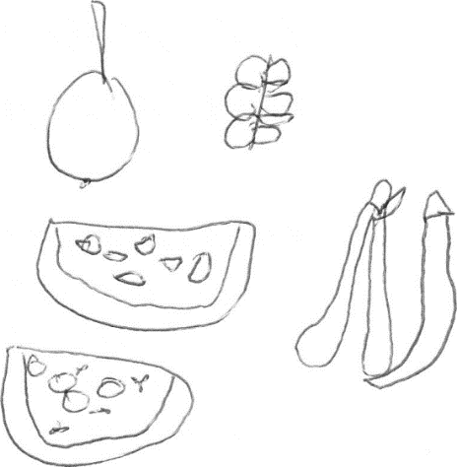
Water and Fruit Routine
Every day at Preschool your child will have a time to have their fruit and lunch. Mostly this will take the form of sitting up at the tables. Other times it may be something like a picnic outside.
Water and fruit duty is a wonderful opportunity for you to join the Preschool program and to observe and interact with your child at work and play and to share information with the teacher and assistant. Come and be part of our Preschool.

Parent Participation
Bittern Preschool relies heavily on the parents of the children attending the centre. At Bittern Preschool your involvement is greatly needed and appreciated and the added bonus for you, the parent, is the many new friendships you will make along the way. Grandma’s, Grandpa’s, Aunties, Uncles, etc; are also welcome to participate. You are welcome to attend the session at any time that suits, you are not required to stay for the full session and even an hour of your time is appreciated and encouraged.

Notices
Watch the NOTICE BOARD in the foyer and StoryPark for the entire goings on at Preschool. Notices will also come home with your children regarding new activities, excursions, or changes at Preschool. Information will also be posted on our Story park app. It is very important that you keep up to date with what is happening at your centre – so don’t forget to keep in touch by reading them! Make sure that you let caregivers who may pick up or bring your child to Preschool know to have a look at the notice board to help keep you informed so that your child doesn’t miss out on anything.

Collector’s Corner
We can recycle just about anything at Preschool, especially when you explore the imagination of young children. So do not throw it away – bring it along to Preschool for us to use. The children use many different types of waste materials in activities such as collage, pasting, carpentry etc. We have a box in the foyer near the sign in book for you to put your goodies in. Some items we love include 1 litre milk cartons, soft wood, good paper, small cardboard boxes, food containers, scrap material, plastic bottle tops, meat trays, margarine containers, empty match boxes, egg cartons, lunch wrap cylinders, and anything that can be cut and glued.
Please do not bring toilet rolls or cigarette packets. Also ensure that items that can be washed are cleaned thoroughly. Some things will not be used immediately and may become smelly. Occasionally the teachers will put up a notice for specific items or to let you know if we have plenty of something.

Delivery and Collection of Children
All children and parents/guardians (or authorized persons) are asked to wait in the foyer until the teacher or assistant opens the playroom doors. While waiting in the foyer you must sign your child in upon arrival and out upon pick-up (this is a requirement of Department of Education and Training). Please Note: You must not write the leaving time until you are picking up your child. Do not leave until your child is safely in the playroom. If another person is collecting your child please let the teacher know by writing their name in the “person to collect” column of the sign in book. The person collecting the child should already be a nominated person on the child’s enrolment card. It is important to keep the child’s enrolment card up to date of people collecting your child and we emphasize that children are only to be delivered and picked up by an authorized person.
When collecting your child, please wait in the foyer or, if directed by a staff member, come to the outside area. Your child is not allowed to leave the indoor or outside areas until a staff member has said that the child can leave and is handed over to you. Please reinforce this with your child.
The reason for signing in and out is not only for ‘attendance records’ at Preschool, but also for safety reasons, so that all children can be accounted for in any emergency, should one occur, such as a fire etc. Naturally we trust that we shall never have the need.
It is very important to your children that they are delivered and collected on time, and there may be a late fee charged for children that are not collected within 15 minutes of the completion of their preschool session. Once your child(ren) remain at the centre for 45 minutes after the session has concluded, the children will be handed over to other services (refer to the Arrival and Departure of Children Policy for further information).
Parents/guardians are responsible for:
- Ensuring the child/ren’s enrolment form includes details of persons who have lawful authority to collect the child/ren
- Ensuring staff are aware that their child/ren have arrived or departed
- Completing the attendance book on arrival and departure
- Ensuring that doors, front gates and playground gates are closed after entry or exit
- Being aware of the movement of other children near gates and doors when entering or exiting the centre
- Ensuring that only their child exits the door or gate with them
- Enabling staff to supervise the children at all times by making arrangements to speak with them outside the staff contact hours
- Supervising their own children before signing them into the program and after they have signed them out of the program
- Supervising other children, including siblings, in their care while attending or assisting at the centre.
- Collecting their child/ren on time at the end of the session/day
- Alerting staff if they are going to be late to collect their child/ren
- Paying the late-collection fine as required

Parking
Ample parking is available in front of the Preschool. It is advisable for all parents when escorting their children to and from the Preschool to use the footpaths and to hold their child’s hand for safety reasons. When reversing your car remember how easy it is not to see a small child behind your vehicle. Please avoid walking on the garden beds at all times.
PLEASE REFRAIN FROM PARKING IN SUDHOLZ STREET. Council requires that those driving to Preschool enter from Frankston-Flinders Road and park in the Preschool car park.

Speed
Please remember that you should keep your driving to a safe speed in the car park at all times.

Your Child’s Work
Your child’s work is a wonderful creation. Children are so proud of their artwork, here are some examples of how you could show interest in their wonderful creations:
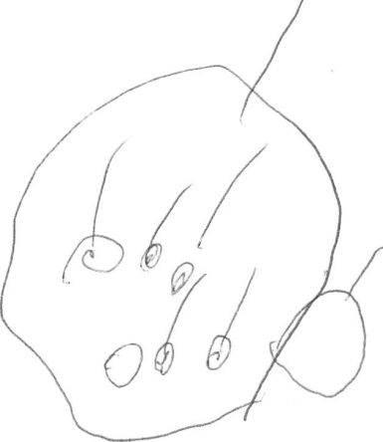
Instead of asking:
“What is it?”
Ask your child to:
“Tell me about this …”
Or
“How did you do this?”

Please do not expect a piece of work to be brought home every day. Many of the activities provided do not allow for the product of your child’s play to be taken home. E.g. block building, puzzles, sand play, etc. Your child’s achievements in these other activities are just as important as the art they bring home. If you want to share in these achievements with your child joining us on fruit duty will provide you with this time.

Birthdays at Preschool
Sharing birthdays at Preschool is really great fun and a very special experience for the child involved. If you would like your child’s birthday celebrated at Preschool a birthday cake or something similar is most welcome. Please feel free to bring a camera to capture the happy days.

Fundraising
Fundraising is an integral part of the Preschool year. It makes a large and essential contribution towards covering the running costs that our Preschool incurs over the period of a year. Money raised from fundraising activities goes towards purchasing new toys and equipment for your child’s use, replacing older items and general amenities.
From time to time, notices will come home with your children from the Fundraising Committee with details of coming events, so please take a moment to read them.
Not only do fundraising activities benefit the Kinder financially, but they are great fun for parents, children and families. Some of the great activities families participated in over the years were:
- Easter Raffle  - Melamine Plates  - Tea Towels  - Bittern Preschool Fete | - Bunnings BBQS  - Trivia Night  - Bogan Bingo  - Cadbury chocolate drive

A Fundraising Officer, elected to be on the committee at the Annual General Meeting, works with a fundraising sub-committee and is responsible for drawing up a yearly plan of fundraising activities.

Maintenance
The maintenance officer, elected from the parent body each year, organizes communal working bees for each term. Notices are displayed listing the jobs needing attention and the tools required. As a ‘community run’ Preschool we require the assistance of families to help keep the kinder in great shape for all our children to enjoy. This also assists us to keep costs to a minimum.
If someone in your family has a particular skill or trade, or just plain old fashioned enthusiasm, let us know; we’d love your input and assistance.

Fundraising and Maintenance Options
The Committee recognises that not all families are in a position to provide hands on assistance, so offer families the option to ‘opt out’ of fundraising and maintenance activities.
All families will receive a form outlining the scheduled fundraising and maintenance activities requiring hands on participation (such as Bunnings barbecues, working bees, Autumn Fete, etc.).
Families choosing to take part will be contacted via email regarding the activities they are to be allocated.
Families choosing to opt out will be required to forego their end of year $100 refund per child and will receive no further communication via email requesting assistance with fundraising and maintenance activities.
Please note that all families will still receive:
- newsletters which will include fundraising updates,
- flyers and order forms for optional fundraising activities (eg. melamine plates, raffles, tea towels, etc)

Procedures

Illness, Emergency Care and Infectious Diseases
Please do not send your child to Preschool if they are ill, even if they wish to attend, as it will usually take you child longer to recover, and may in turn pass on the illness.
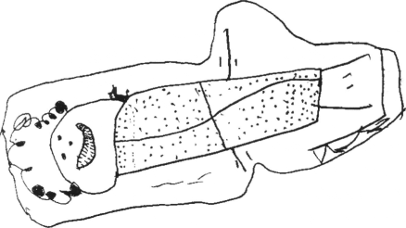
In the event that a child becomes ill during a Preschool session, a staff member will contact the parent/guardian, but if unavailable will then contact a person on the emergency list. The contact person will be asked to collect the child. The child will be made as comfortable as possible and taken care of until somebody arrives to take them home. Medical attention will be sought for your child in an emergency situation.
No medication can be given to a child unless prior arrangements have been made with the teacher and signed into the medical book by the parent/guardian.
Please ring the centre on 0407 622 325 if your child is to be absent from Preschool.
If your child is suffering from an infectious disease, please inform staff so that a notice can be displayed in the entrance notifying all families. No child will be admitted to the Preschool with signs of illness or infection.
Please do not send your children to Preschool with the following illnesses:
Illness | Do not return to Preschool until…
- Amoebas  - Campylobacter  - Salmonella | Diarrhoea has ceased
- Chicken Pox  - Measles  - German Measles | Fully recovered
- Conjunctivitis | Discharge from eyes has ceased
- Diarrhoea  - Vomiting | Fully recovered
- Diphtheria | Medical certificate is received
- Hand, Foot and Mouth Disease | Blisters have dried
- Head Lice | Treated
- Hemophilus Type B (Hib) | Medical certificate is received
- Hepatitis A | Medical certificate is received
- Herpes | Lesion has ceased weeping
- Impetigo | Appropriate treatment has commenced
- Meningitis | Well
- Meningococcal Infection | Adequate carrier eradication therapy has been completed
- Mumps | Fully recovered
- Poliomyelitis | Medical certificate is received
- Streptococcal  - Scarlet Fever | Child has received antibiotic treatment for at least 24 hours
- Scabies  - Ringworm | Appropriate treatment has commenced
- Trachoma | Day after appropriate treatment has commenced
- Tuberculosis | Medical certificate is received
- Typhoid Fever | Approval to return has been given by the Secretary
- Whooping Cough | 5 days after starting an antibiotic treatment

In the case of a disease with more serious social implications, all parents /guardians will be asked to attend an information session. A qualified health worker experienced in that particular disease will conduct this so that correct information can be given to parents covering all aspects of the disease.

If your child has the flu or any minor illnesses, including a green runny nose, please keep them at home.

As part of our Covid Safe plan, children, staff and volunteers cannot attend whilst unwell. If a person is to present with COVID-19 syptoms during their time at Bittern Preschool they must leave and get tested. They cannot return until a negative COVID-19 test is completed and all syptoms have resolved.

Excursions/Incursions
During the Preschool year special events may be organized by the staff for the children. The Bittern Preschool is committed to providing a varied and developmentally appropriate educational program with as many firsthand experiences as possible. One method of providing such experiences is through excursions/incursions.
With all excursions the service is committed to:
- Providing a high level of safety for children at all times
- Compliance with all regulatory requirements, and,
- Providing activities that are developmentally appropriate and linked to the educational program.

Where staff believe that an excursion would enhance the educational program they will submit a request for approval to the committee. As part of the request they will clearly outline:
- The details of the excursion (including how the excursion relates to the program provided for the children),
- the objectives and outcomes of the excursion,
- the mode of transport,
- the cost of the excursion to the service, and,
- the effects, if any, on the children’s current attendance times.
As part of the approval process, the committee will consider;
- whether the cost can be met by the allocated figure as set in the budget,
- whether children other than those attending the Preschool group may participate in the excursion,
- what impact the disruption to normal program times could have on the users of the Preschool, and,
- If there are any changes to the usual working arrangements of the staff due to the excursion, in accordance with the appropriate awards or agreements.
The Preschool will then provide parents/guardians with a permission form to complete for their child to participate in the excursion. This will detail parent attendance expectations, date, time, location, transport, and any other information that is relevant to that particular activity.
The Bittern Preschool has included costs for incursions/excursions within the fees to reduce on-going requests for financial contributions from families and allow all children to participate in these happy days. On occasion, there may be additional voluntary excursions offered that exceed this allocation and in these instances parents may be asked to contribute if they wish their child to participate.

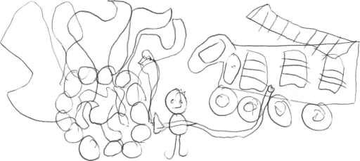
Emergency Evacuation Procedure
There are whistles and “collective rope” in the Preschool main room near the teacher’s office. In an emergency, a whistle will be blown and the children will be directed to the appropriate exit door. The assistant will collect the attendance book and the key to the gate if required. Once outside the teacher will count the children whilst the assistant checks inside thoroughly to ensure all children are safely outside. The assistant will contact the fire brigade if possible/necessary.
In case of emergency situation the children will be evacuated to either the enclosed play area next to Bittern Hall or the double gates at the rear of the Preschool via the emergency gate. Parents are asked not to come down to collect their children until notified by the Preschool committee. This will enable staff to ensure that all children are accounted for and safe until the situation has been assessed and appropriate action has been taken. This will also help to avoid confusion and panic.
During the year your child will participate in “fire drills”. There will be one fire drill per term. Parents will be notified prior to and after each “fire drill”.

Bush kinder
In 2021 we implemented what is known as ‘Bush Kinder’. This is a fantastic opportunity for the children in the 4 year old groups to explore nature around our kinder.
At Bittern Preschool we are passionate about the importance of outside and nature play in a Childs learning and development. Children are natural learners, and bush kinder will aide your child in this learning. Bush kinder provides your child the opportunity to play and learn in a natural space using the materials provided by nature.

Your child will have the opportunity climb trees, balance on broken branches, discover the birds and plants that interest them, play in the rain and the mud and explore their understanding of the natural world around them.

Bush kinder will be held at a space connected to Bittern Primary school. Not only will your child have the natural space to explore and learn, they will at times have the opportunity to utilise the schools library and the Perceptual Motor Program (PMP) room. Both of these provide extended learning opportunities for your child.

Studies have shown that children who are exposed to play outside in natural environments have:
- Increased confidence, motivation and concentration.
- Increased social, physical and language skills.
- Deeper conceptual understandings and respect for the natural environment.
- Increased social and imaginative play.
More varied risk-taking behaviours and positive dispositions towards risk and challenge.
Story Park
To keep parents updated with their child’s progress at Bittern Preschool we have implanted the use of ‘Story Park’. Story Park is an app that is linked between yourself and the kindergarten where teachers will upload all of your child’s observations and program, you will be able to see everything that is uploaded of your child. Its also used as a tool to hand out newsletters and all announcements and information in a paper free way. Before the start of term one you will receive an email invitation to sign up.
Story Park gives you an immediate opportunity to be involved in your child's day through:
- Conversation
- Photographs
- Routines

It also gives you the immediate opportunity to be involved in your child's learning through:
- Goal Setting
- Program Development

Policies

The policies of a Preschool are the documented rules by which a Preschool operates. An overview of the current policies of Bittern Preschool is outlined below. For a more comprehensive view of the current policies please see the Policy Book which is located in the foyer. As a member of the preschool you are required to abide by these policies at all times.

Fees Policy
Payments of Preschool fees are made one full term in advance to ensure your child’s place is available.

2022 Fees
TOTAL ANNUAL FEE AMOUNT
Group | Full Fee Paying |  |  | Health Care Card Holders  (Validation reviewed each term)
Four Year Old Groups | Total Fee |  | $2,100 | Total Fee |  | $100
 | less refundable holding deposit | - $100 |  | Refundable holding deposit - $100
 | Remaining fees | $2,000
 | 5% discount if full year is paid in advance) | $1900
Three Year Old Groups  (Double Session) | Total Fee | $1300 |  | Total Fee | $100
 | less refundable holding deposit | - $100 |  | less refundable holding deposit | - $100
 | Remaining fees | $1,200 |  | Remaining fees | $1,800
 | 5% discount if full year is paid in advance) | $1,140 |  | 5% discount if full year is paid in advance) | $1,710

2022 Payment Schedule
4 Year Old Groups
Fee | Full Fee Paying by Term | Full Fee Paying Annual  (5% discount) | Health Care Card Holder | Due Date
Holding Deposit | $100.00 | $100.00 | $100 | 15/10/2021
Term One Fees | $500.00 | $1900.00 | - | 16/11/2021 Paid at the AGM/Info Night
Term 2 Fees | $500.00 | _ | - | First Week of Term One
Term 3 Fees | $500.00 | _ | - | First Week of Term Two
Term 4 Fees | $500.00 | _ | - | First Week of Term Three
For those who have paid a $100 deposit, a refund is available at the conclusion of Term 4 for adult participation and attendance at 3 specified calendar events per enrolled child. (Events such as: Bunnings barbecues, working bees, Autumn Fete, etc.)

3 Year Old Groups
Fee | Full Fee Paying by Term | Full Fee Paying Annual  (5% discount) | Health Care Card Holder  (No Government Concession Available) | Due Date
Holding Deposit | $100.00 | $100.00 | $100.00 | 15/10/2021
Term One Fees | $300.00 | $1,140.00 | - | 16/11/2021 Paid at the AGM/Info Night
Term 2 Fees | $300.00 | _ | - | First Week of Term One
Term 3 Fees | $300.00 | _ | - | First Week of Term Two
Term 4 Fees | $300.00 | _ | - | First Week of Term Three
A $100 refund per child is available at the conclusion of Term 4 for adult participation and attendance at 3 specified calendar events per enrolled child. (Events such as: Bunnings barbecues, working bees, Autumn Fete, etc.)

Term one fees are due at the Annual General Meeting [AGM] held in November 2021; a full term’s fees is required to secure your child’s placement.
All fees for term two, three, and four fees are due in the first week of the term prior to that being paid for (e.g. term two fees are due in the first week of term one).
Unpaid fees can result in your child being excluded from Preschool until the overdue amounts have been paid.
The President will notify the family of any decisions made. Again this position is filled by volunteer parents who do not wish to follow up families for payment, therefore; it is the responsibility of each family to contact the Administrative Director in the case of genuine financial difficulty in which case a payment plan may be devised to ensure fees remain paid in a timely manner. Please be assured that such circumstances will be treated with the utmost discretion, understanding and sympathy by the committee.
As a matter of last resort, the committee reserves the right to exclude a child from Preschool until the overdue amounts have been paid.
If your child is absent from the Preschool for any length of time, to ensure your child’s position is held at the Preschool, full session fees are payable without reduction for time missed. For withdrawal procedure, please refer to Refunds below.
Please Note:
If fees have not been paid by the end of the Preschool year, any future child enrolled at Bittern Preschool may not be able to attend until the outstanding fees have been paid (at the discretion of the Committee of Management.)

Payment Procedure
To limit cash handling by volunteer parents, staff and to avoid storing cash at the Preschool we ask all parents to pay directly into the Bittern Preschool account held at the Bendigo Bank in Hastings or via internet banking.

Direct Deposit Banking Details
Account Name | Bittern Preschool
BSB | 633 000
Account Number | 144376860
Reference | Please include your child’s name and the relevant term:  eg. SMITH John T2

If you are a Health Care Card Holder it is your responsibility to make sure that the Fees Officer is aware and has sighted and recorded the cards expiry details. The Health Care Card must be current for the period you are paying for.
Please Note: Bittern Preschool takes no responsibility for misplaced cash. There are to be no cash/cheques placed in the fees box under any circumstances.

2022 Fees Discount
A 5% discount is offered to both 3 and 4 year old families if the full amount for the year is paid upfront at the 2021 Annual General Meeting only.
Households with more than one child attending will receive a 5% discount on the second child’s fees (lowest fees) only when payment is made on or prior to the due date. If you are paying for your children upfront at the AGM the second child’s payment will only receive the 5% discount once.
(Discounts apply to remaining fees after the holding deposit is paid)
The committee will review annually whether discounts will be offered each year and the amount that will be offered.

Health Care Card Holders
We apply for the Kindergarten Fee Subsidy and pass this on by way of reduced fees for families who hold a current concession card. This subsidy is allocated by the government half yearly. Application for funding for the second half of the year takes place in July. All families will need to present their current Health Care Card or Pension Card on expiry of the old one in order to be entitled to the reduced fees. Any families who no longer hold a current concession card will not be eligible.

Refund Policy
In the case where a family has the need to withdraw their child from the Bittern Preschool they must give written notice to the Bittern Preschool 4 weeks or more prior to the child being withdrawn from Bittern Preschool.
Fees are non-refundable. Refunds/pro rata refunds apply only in the following cases:
- Up to the commencement of Term 1, a full refund of the fee deposit may be given on written application to the committee. The decision will be at the committee’s discretion.
- Up to the commencement of Term 1, a partial refund of the fee deposit will be given to families eligible for the kindergarten fee subsidy on sighting the supporting documentation.
- If a family becomes eligible for the kindergarten fee subsidy during a term, a full refund of the applicable term fees (and fee deposit for Term 1) will be provided. Note that fees may apply for programs offered for more than ten hours per week.
- On commencement of Term 1, no partial refunds for term fees will be available (except as applied in point 3 above). If the child leaves before the end of the term, no pro-rata refund will be available for that term. Written notice of departure is required prior to the invoicing period for the next term.
- The committee may consider a partial refund in exceptional circumstances. Applications for a refund must be in writing and must clearly outline the reasons why the child ceased to attend the centre. Any refund will be at the discretion of the committee and will be assessed on a case-by-case basis. An administration fee may be applied.
- Refunds may be provided when the child’s place is able to be filled after the child has left the centre.
There will be no refund of fees due to a child’s short-term illness; public holidays; family holiday during operational times; closure of the centre for one or more days when a qualified staff member is absent and a qualified reliever is not available; closure of the centre for staff training days; or closure of the centre in extreme and unavoidable circumstances.

Enrolment Policy
Registrations for both three and four year old preschool are managed centrally by Mornington Peninsula Council.
Mornington Peninsula Council Contact Details:
Phone Number | 1300 850 600
Email Address | kindergarten@mornpen.vic.gov.au

3 year olds
Children may not attend preschool until they have turned 3. Those children who turn 3 by April 30th may attend after their birthday, or alternatively wait until the next calendar year to enrol.
Please note that full payment in advance of term one fees is required to hold a position, regardless of when a child turns 3 and commences attendance at preschool.

4 year olds

Children must turn 4 years by April 30th in the year they attend Preschool.

No Jab, No Play Legislation
Under the proposed 'No Jab, No Play' legislation, all parents/guardians seeking to enrol their child at an early childhood service in Victoria will be required to provide evidence that the child is:
- fully immunised for their age OR
- on a vaccination catch-up program OR
- unable to be fully immunised for medical reasons.
'Conscientious objection' will not be an exemption.
From 1 January 2016 onwards parents/carers seeking to finalise enrolment for their child in childcare or kindergarten will need to provide:
- an Immunisation History Statement showing their child's vaccinations are up-to-date for their age according to the immunisation schedule (or lists which vaccines they have a medical contraindication to), OR
- a completed Medicare Immunisation History Form IMMU13 as evidence their child is on a vaccination catch-up schedule.
Being registered on a waiting list for a place at an early childhood service is not a confirmed enrolment, and the requirement to be fully immunised will apply if places are offered and confirmed after 1 January 2016.

Late Collection of Children Policy
It is important for parents to keep their child’s emergency contact details up to date. For the committee to fulfill its obligations to parents and children under the Children’s Services Regulations and insurance policies, it is necessary to have a policy outlining the procedure that will take effect should any child be:
- Collected late from preschool
- Not collected from preschool due to an emergency or other situation
A child is considered ‘late’ if not collected 10 minutes after the end of the session. The Teacher will ring the parent/guardian, followed by the emergency numbers as detailed in the enrolment information provided by the parent. Two adults are to remain with the child, at Bittern Preschool at all times, e.g. Teacher/Assistant and/or Committee member/late pickup parent.
If after forty-five minutes has elapsed from the end of a session, and contact still has not been made with the parent/guardian or any other nominated carer, the Teacher (or other person in charge) will contact the Hastings Police and advise them of the situation. The Hastings Police will then make the arrangements which they deem appropriate for the collection and care of the child.
Where it has been determined that a child has been ‘late’, that child’s parent(s)/guardian(s) will incur a financial penalty to cover costs by Bittern Preschool in attempting to locate them, and for costs incurred in caring for the ‘late’ child. This penalty shall be ten dollars ($10.00) for every fifteen (15) minutes of lateness, and the ‘late’ child shall not be re-admitted to Bittern Preschool until such a penalty has been paid.
If you are unavoidably detained please contact the teacher on 0407 622 325 so they can explain this to your child and save them from unnecessary worry. Some children are quite distressed with this, and it can affect their desire to return to the Preschool.

Behaviour Guidance Policy
Bittern Preschool is committed to:
- Respecting the importance of positive interactions and relationships between children, families, staff and committee
- Acknowledging that children have the same rights as adults and recognising the diversity that exists in everyone
- Protecting children from aggression by providing them with a safe and secure environment, and the opportunity for positive and respectful interactions with adults and other children
- Recognising that children’s behaviour reflects their level of development and is influenced by a range of factors
- Providing a learning environment that supports the growth, wellbeing and development of the whole child
- Respecting cultural practices and beliefs and working in partnership with parents/guardians and other professionals with issues relating to the guidance of a child’s behaviour
- Encouraging children’s learning in identifying their own rights, needs and feelings with those of others, to interact effectively and, in doing so, to gain an understanding of empathy
- Engaging only in practices that are respectful of, and provide security for, children and that in no way degrade, endanger, exploit, intimidate or harm them psychologically or physically
- Reflecting the values, attitudes and current recommended strategies that promote positive behaviours
If at any child presents with challenging behaviours, staff will follow the behaviour guidance policy steps:
1 – Invite parents to assist in managing behaviours
2 – Develop a behaviour guidance plan in collaboration with parents/carers.
3 – Continually review and reflect strategies in place

See policy for further details.

Procedure for Dealing with Complaints Policy
If you have any concerns, problems or queries about the program or any other issue affecting your child either at home or at the Preschool, please do not hesitate to talk to the Teacher. It may be easier to make a time where there are no other children or parents, and the Teacher has time to discuss the issue with you.
If you have any complaints regarding the care or safety of your child, please address them in writing to the President. If the Committee is unable to resolve your concerns, you may wish to contact an authorised officer of our local region (South Eastern Victoria) of the Department of Education and Training (DET) at sevr@edumail.vic.gov.au.
For further information, you can also contact the Department on 1300 307 415 or by email on licensed.childrens.services@edumail.vic.gov.au
Your feedback about the services offered at Bittern Preschool is highly valued. Please feel free to discuss matters of concern at any time.
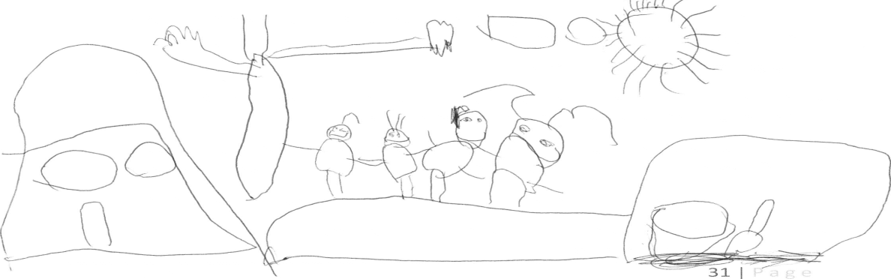

Privacy Policy
The Bittern Preschool Privacy Policy is available in the front foyer of the Preschool. All Committee members are required to sign a privacy declaration before their commencement on the Committee.

Photography Policy
During the year photos will be taken of your child. During your orientation session you will be given a form to complete, if you do not wish your child to have their photo taken please ensure you complete this section on the form.

Toilet Training policy
Any Parent of a 3 year old or 4 year old child that isn’t toilet trained when they start kinder will have to inform the teacher and arrange a meeting to collaboratively develop an individual toileting plan. Parents will have to provide the kinder with gloves, nappies, creams, wipes, disposable nappy bags and any other supplies as requested by the Teacher. It is important that this policy be followed due to health regulations.

Grievance and Discipline Policy
The Committee of Management, in conjunction with the employee and/or union shall establish appropriate mechanisms for determining that staff-management relationships are satisfactory.

Children of Staff Policy
No child or children of staff members are permitted to be at Preschool whilst the staff member is on duty, during contact time.

Sun Protection Policy
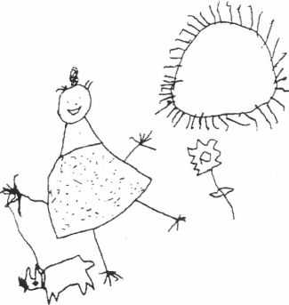
The Bittern Pre School is committed to providing all service participants (especially children) with protection from the harmful effects caused by exposure to the sun's ultraviolet radiation, during all aspects of the program.

In an endeavor to educate the children and parents /guardians of the harmful effects of the sun's ultraviolet radiation Bittern Pre School will:
- Provide all parents /guardians with a copy of this information when their children start attending the Preschool.
- Keep a supply of spare and laundered sun hats.
- Maintain a supply of SPF 30+ broad spectrum, water-resistant sunscreen in the foyer of Kindergarten ready for families to use.
- Provide sheltered areas from direct sunlight e.g. a large tree, canopy, or artificial cover.
Bittern Preschool operates under a Sun Smart Policy, therefore, in Terms One and Four, parents must supply their children with:
- A sun hat providing sun protection. These need to provide shade to the face, back of neck and ears. Baseball caps are not acceptable, as they do not provide sufficient protection. "Legionnaire" style hats or bucket hats are recommended.
- Suitable clothing for sun protection: a t-shirt with sleeves or equivalent and shorts/pants. Sleeveless tops are not permitted.
To play outside all children must wear a sun hat during Terms 1 and 4 whilst outdoors at Preschool.
REMEMBER SLIP, SLOP, SLAP

Healthy Eating Policy
Food at Bittern Preschool is supplied by the families.
Parents will be providing lunch for their child and this lunch could contain the following:
  - Sandwiches – vegemite, honey, meat, salad etc.
  - Soup
  - Salads
  - Crackers and cheese
  - Fresh Fruit
  - Muesli bars, fruit bars
  - Dried fruit
  - Rice crackers
  - Plain biscuits
  - Yogurt/fruche
  - Any other nutritious snack

Children are discouraged to bring:
- Sweets/lollies
- Chips/crisps
- Chocolate
- Sweet biscuits
- Soft drink/cordial/juice
- Cakes (nutritious, homemade cakes/muffins are acceptable)

Defining, determining and monitoring an allergy
See anaphylaxis policy. Allergy information will be displayed in the kitchen and staff/volunteers made aware of this.
When an entire meal or snack has not been provided, and the child has no food for the time in kindergarten, the staff will prepare dry biscuits and vegemite and sultanas. If your child has a known allergy to any of these items you are responsible for making sure alternatives are available, wherever possible staff will substitute those items with healthy alternatives. Should no alternative be available, the family will be contacted to rectify the situation.

Mealtimes and/or snacks
The kindergarten provides a safe environment that promotes appropriate mealtime behaviours and supports children to make healthy food choices.
Safe eating behaviours may include limits. For example, children do not move around while eating; children sit on chairs when eating at tables. Staff will supervise children during meal times.

Accommodating different cultural practices and behaviours
Cultural practice and behaviours will be included. For example, children who eat with their hands, or are fed by a family member with their hands, in a preschool that promotes self-help skills with eating utensils. This will be a partnership with the parents to facilitate cultural differences.

The role of students and volunteers during mealtimes and/or snacks
The kindergarten staff support and guide students/volunteers during meal and/or snack times; role model healthy eating practices and socially appropriate behaviours; and explore and discuss different cultural, social and family lifestyles that influence nutrition.

Special occasions and celebrations
Bittern Preschool is a culturally sensitive centre and is aware that families may celebrate or participate in a variety of national days or celebrations. The National Heart Foundation recommends that snack foods such as, cakes, biscuits, and takeaway foods are limited to once a week. The kindergarten encourages a balance between healthy eating choices and those foods which are considered unhealthy.
The preschool staff may also provide opportunity for whole group participation of significant cultural or national days through the preparation of food, but will adhere to the healthy eating guidelines. For example, it is understandable that kindergartens may decide to cook fried rice to celebrate Lunar New Year, and offer children the opportunity to use chopsticks when eating.

Healthy eating and dental health
Dental health should be considered by the service when planning, providing or encouraging healthy eating choices.

The kindergarten may detail its strategy in regards to healthy eating and dental health. For further information refer to: the Australian Dental Association (http://www.ada.org.au/).

Orientation Policy
To create an environment that supports, reflects and promotes equitable and inclusive behaviors and practices, and respects individuals and groups of people, it is crucial that a preschool examines its value and belief systems in regards to families attending the service. In doing so, we need to have an extensive orientation process that caters to the needs of individual children as well as keeping within the regulations as outlined in the Children’s Services Regulations 2009.
The purpose of the Orientation Policy is to:
- State that the Preschool recognizes and values the differences and similarities that exist in children, families, staff/carers, management/coordination unit staff, students, volunteers and the wider community.
- Support the children and families within the Preschool to settle in and form relationships with peers and teachers.
- To ensure that we have a process in place for children starting 3 year old preschool that are not yet 3 at the beginning of the school year.

Enrolling Families and Children into the Service
- Enrolment and orientation is often a family’s first impression of a preschools’ diversity and equity values.
- The preschool provides support to families during the enrolment process. The parents of new children starting are to attend the AGM and information evening as well as orientation days at the beginning of the school year.
- Families and children who are using early childhood learning centres for the first time require support and guidance from services. The settling in process can be stressful for many families, particularly those who have different culture or language backgrounds.
- The preschool provides information about the range of strategies used to communicate with families and children to meet their individual needs in this Parent Information Booklet given to each family upon enrolment.

Process of orientation for children that are not yet 3 at the beginning of the school year
- Children under the age of 3 cannot be catered for at the preschool as per the Education and Care Services National Regulations 2011 in regards to child / staff ratios, staff definition and qualifications and physical layout of the preschool building.
- The child may need to attend the initial orientation day as outlined in the letter of offer to meet the Teacher and have a short introduction to the preschool environment.
- The Teacher will communicate with the family about an orientation plan for the child. This will involve visits to the preschool no longer than 1.5 hours in length for the purpose of becoming familiar with the routine of the session, forming relationships with peers and building up a rapport with the teacher. The parent is to stay at the preschool during this orientation period, which will be tailored to meet the individual needs of the child.
- Once the child turns 3 they are to attend the hours as outlined in the letter of offer.
- The family must pay full fees during this orientation period to confirm their place at the preschool.

Bittern Preschool Committee of Management

The Preschool Committee is a voluntary group of people made up from the parents of the Preschool and other interested community members. They are elected at the Annual General Meeting (held in November) and consist of the following:

Executive Members:
- President
- Vice President
- Secretary
- Treasurer

General Members
- Fundraising Officer (Plus 3 or more people to form a sub-committee)
- Maintenance Officer
- Grants Officer
- Group Representatives (2 per 4 year old group, one per 3 year old group)
- General Committee Members

The Committee meets once a month at the Preschool and is responsible for the administration and financial management of the Preschool. It is the employer of all staff. Teacher’s and Committee Member’s reports are also presented and a great deal of important general business is discussed.

The meetings are open meetings, meaning all are welcome- both Committee and non-committee members. The success of the Preschool year is directly dependent upon your ongoing active support of the Committee and its undertakings. So why not join in and make it a happy and successful time for both you and your child.

It is also a legal requirement that the Committee exists, in its entirety. Without a full committee our Preschool will not be permitted to continue. The Committee are looking forward to a happy and productive year working alongside you and your family and hope it will be a wonderful time for parents and children to meet, socialise and form new friendships.

Bittern Preschool Committee Members' Position Descriptions

President
- The President has a very important role within the Preschool, which entails decision-making and chairing committee meetings.
- The President can also use their judgement to delegate specific duties to the appropriate person.
- The President will be looked upon for leadership and as such should be able to communicate well with committee members, teachers and parents.
- Attend, chair and provide a report for monthly committee meetings.
- S/he will have access to information that is confidential so will need to be a trustworthy and responsible person.
- Support the staff and work with them as a team. Respect the staffs’ professional opinions and take them into account when making decisions.
- Make decisions or initiate discussions at Committee meetings.
- Ensure the constitution is upheld.
- Assist and support other Committee members, or delegate to the Vice President.
- Liaise with the Department of Education and Early Childhood Development (DEECD).
- Required to participate in online DEECD training.
- Read material supplied by DEECD and Kindergarten Parents Victoria (KPV)
- Work with the Staff, Policies Officer and Secretary to ensure the Preschool is meeting all regulatory and statutory obligations.

Vice President
- The Vice President assists the President and the Secretary whenever required.
- Should the President be absent for any reason then the Vice President will fulfill their role.
- Attend and provide a report for monthly committee meetings.

Secretary
- The Secretary records all incoming and outgoing mail.
- S/he collects the mail on a regular basis and distributes it to the appropriate person.
- Typing is a key part of this position, so direct access to a computer is a must (computer available at Preschool).
- File all correspondence and minutes.
- Accurately record the minutes of all meetings and related actions, and maintain these appropriately.
- Be aware of any ongoing issues.
- Prepare relevant documentation prior to Committee meetings. Develop the agenda with the president.
- Draft any necessary letters.
- The Secretary is one of the central communicators of the Committee.
- Attend, minute and provide a report for monthly committee meetings.

Treasurer
- Attend and provide a report for monthly committee meetings.
- Collect invoices, receipts as required
- Enter all invoices
- File all paperwork
- Print and file all bank statements
- Use bank statements to reconcile all accounts.
- Produce Profit & Loss to Budget reports and send to President monthly
- Complete BAS Statements quarterly (GST & PAYG)
- Deposit funds when required
- Write Cheques when required
- Liaise with Auditor/ Accountant providing information as required
- Liaise with Administrative director

Fundraising Officer
- The Fundraising Officer is responsible for coordinating fundraising activities on behalf of the Preschool.
- S/he will coordinate the Fundraising Sub-committee.
- S/he is responsible for advising Group Representatives of their requirements for fundraising.
- Attend and provide a report for monthly committee meetings.

Fundraising Sub-Committee
- The Fundraising Sub-Committee has no restrictions on the number of members and generally 'the more the merrier'.
- Assist the Fundraising Officer to plan, conduct and follow-up on fundraising activities.

Maintenance Officer
- The Maintenance Officer is responsible for maintaining the Preschool.
- The Maintenance Officer is required to draw up a working bee roster and coordinate materials and activities for the day.
- The Maintenance Officer may need to contact the Shire to request that certain works be carried out and also organise for repairs to be attended to.
- Attend and provide a report for monthly committee meetings.

Grants Officers
- Researches and applies for any grants the Kinder may be eligible for.
- Attend and provide a report for monthly committee meetings.

Group Representatives
- This is a job that involves direct liaising between the Teachers and the parents in each 3 or 4 year old group.
- Collect and Deposit money for excursions, incursions and fundraising.
- Ensure permission forms are signed and handed in for each child.
- Attend monthly committee meetings.
- Wash the bush kinder clothing on a monthly roster, 4 year old groups only.

General Committee Members
- Responsible for assisting staff and committee members as required.
- Attend monthly committee meetings.

All Committee Members
- All committee members have a responsibility to the Preschool and the privilege of voting on important decisions made.
- All committee members may have access to information that is confidential so will need to be trustworthy and responsible people. All Committee members will be required to read the Bittern Preschool Privacy Policy and sign a privacy declaration.
- It can be hard work at times but most would agree that the more you put in the more you gain from the experience.
- A sense of purpose that unifies the committee is our motivation to provide the best for our children. We are doing it for the children, so we are doing it from the heart.

Contact Numbers

Name | Phone Number
Bittern Preschool | 0407 622 325
Sarah Norris | 0468 921 069

Please keep this booklet for future reference and to write down Committee member’s phone numbers as they become available in case you ever need to contact them.

